Project Report

  - Jacob Lamoureux

  - Project 3
  - March 31, 2026

Table of Contents
Introduction 3
Methods 3
Variable Selection 3
Data Loading and Inspection 3
NHTS Plot Construction 4
NGSIM Plot Construction 4
Intelligent Driver Model 5
Results and Discussion 5
Bar Chart: Vehicle Count by Fuel Type 5
Histogram: Vehicle Age Distribution 6
Boxplot: Vehicle Age by Make 7
Time-Series Dashboard: Trajectory 10 8
IDM Simulation: Simulated vs Real Trajectory 9
References 11

Introduction
The Federal Highway Administration (FHWA) is the branch of the US Department of Transportation responsible for managing the national highway system and supporting transportation planning across the country. To help engineers and planners make better decisions, the FHWA collects large amounts of data on how people travel and how vehicles behave on the road. Two of the most useful datasets produced through these efforts are the National Household Travel Survey (NHTS) and the Next Generation Simulation (NGSIM) dataset.
The NHTS is a nationwide survey that collects information on household travel behavior and vehicle characteristics. The NGSIM dataset was collected to support the development of traffic simulation tools, and contains detailed time-series records of vehicle positions, speeds, and accelerations recorded on US highways (FHWA, 2006). It is one of the most widely used datasets in the study of driving behavior.
The goal of this project is to load, inspect, and visualize both datasets using Python to help a transportation planning group better understand vehicle fleet trends and real-world driving behavior. This includes producing visualizations of key NHTS variables, producing time-series plots from the NGSIM dataset, and implementing the Intelligent Driver Model (IDM) to simulate and compare vehicle trajectories.

Methods

Variable Selection
From the NHTS dataset, three variables were selected. Fuel type was chosen because it is one of the most relevant characteristics of the current US vehicle fleet, especially as the industry shifts toward electric vehicles. Vehicle age was selected because it is a continuous variable that describes how old the fleet is on average, which can reflect household income and the pace of technology adoption. Vehicle make was included as a grouping variable to show how age varies across manufacturers.
From the NGSIM dataset, time, position, speed, and acceleration were selected for both the leader and follower vehicles because they fully describe the motion of each vehicle throughout the observation period. A gap distance variable was also derived by subtracting follower position from leader position at each time step, since vehicle spacing is a key characteristic of car-following behavior. Trajectory 10 was selected for all NGSIM visualizations and the IDM simulation.

Data Loading and Inspection
Both datasets were provided as CSV files and imported into Python using the pandas read_csv() function. Once loaded, the head(), info(), and describe() methods were used to inspect the structure of each dataset and confirm that columns were correctly formatted and contained reasonable values. Missing values were checked using isnull().sum(). For the NHTS dataset, rows missing a vehicle make value were dropped using dropna() before any plots requiring that variable were produced, since missing make values would result in unlabeled or incorrect groupings in the boxplot.

NHTS Plot Construction
The bar chart comparing vehicle counts by fuel type was built by first calling value_counts() on the fuel_type column to count the number of vehicles in each category, then dropping any missing values with dropna(). The resulting counts were passed to the pandas plot() function with kind set to bar. A viridis color palette from seaborn was applied across the bars using sns.color_palette(), with the number of colors matched to the number of fuel type categories. X-axis labels were rotated 65 degrees to prevent overlap, and axis labels and a title were added using standard matplotlib functions.
The histogram of vehicle age was produced using matplotlib's plt.hist() function applied to the vehicle_age column, with the number of bins set to 40. A custom fill color and edge color were specified to demonstrate matplotlib customization beyond the default appearance. Axis labels and a title were added using plt.xlabel(), plt.ylabel(), and plt.title().
The boxplot of vehicle age grouped by vehicle make was produced using the pandas boxplot() method, with column set to vehicle_age and by set to make. The figure size was set large enough to display all manufacturer labels along the x-axis. Labels were rotated 90 degrees using plt.xticks(rotation=90), and the automatic pandas subtitle was removed using plt.suptitle('') to produce a cleaner figure.

NGSIM Plot Construction
The NGSIM dataset was filtered to trajectory 10 by selecting only rows where the trajectory_number column equaled 10. The gap distance variable was derived at this stage by subtracting the follower_position column from the leader_position column. The time array was extracted as a numpy array to serve as the x-axis for all time-series plots.
The time-series dashboard was produced using plt.subplots() with a 2 row by 2 column layout, creating four subplot panels within a single figure. The top-left panel shows position over time for both vehicles, the top-right panel shows acceleration, the bottom-left panel shows speed, and the bottom-right panel shows the derived gap distance. In each panel, separate lines were plotted for the leader and follower using distinct colors, and legends were added to identify each line. Transparency was applied to the acceleration lines using the alpha argument to make overlapping data easier to read. A shared title was added to the overall figure using fig.suptitle(), and plt.tight_layout() was called to prevent labels from overlapping between panels.

Intelligent Driver Model
The Intelligent Driver Model (IDM) is a car-following model developed by Treiber, Hennecke, and Helbing (2000) that computes vehicle acceleration based on current speed, gap to the vehicle ahead, and relative speed between the two vehicles. The full IDM acceleration equation is:
a_IDM = a * [1 - (v/v0)^delta - (s*/s)^2]
Where s* is the desired minimum gap, computed as:
s* = s0 + v*T + (v * delta_v) / (2 * sqrt(a * b))
The model was implemented as a Python function called idm_acceleration() that takes the follower's current speed, gap distance, and relative speed as inputs along with all model parameters, and returns the computed acceleration. A minimum gap floor of 0.1 m was applied inside the function to prevent division by zero in cases where the gap approached zero.
The simulation was run using Euler integration with a time step of 0.1 seconds, matching the NGSIM sampling rate. At each time step, the gap between the real leader and the simulated follower was computed, the IDM function was called to get the acceleration, and the follower speed and position were updated using the standard Euler equations: new speed equals old speed plus acceleration times dt, and new position equals old position plus speed times dt. Speed was floored at zero to prevent the simulation from producing negative speeds. The simulated follower was initialized at the same starting position and speed as the real NGSIM follower for trajectory 10. Parameters used were a desired velocity of 30 m/s, minimum spacing of 2 m, time headway of 1.5 s, maximum acceleration of 1.0 m/s^2, comfortable deceleration of 1.5 m/s^2, and an acceleration exponent of 4, consistent with standard IDM values from the original literature (Treiber et al., 2000).

Results and Discussion

Bar Chart: Vehicle Count by Fuel Type
As shown in Figure 1, the bar chart shows that gas vehicles make up the large majority of the surveyed fleet by a wide margin. Hybrid and diesel vehicles make up a small but visible share, while electric and plug-in hybrid vehicles represent only a small fraction of the total. This is consistent with current national fleet data and reflects the reality that despite growing interest in electric vehicles, the US fleet is still largely gas-powered. For transportation planners, this means that emissions reduction strategies cannot rely solely on electrification in the short term and must also account for improving the efficiency of the existing gas fleet.
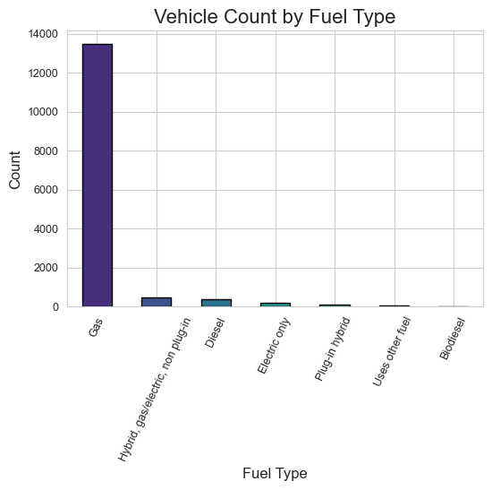
Figure 1 - Bar Chart

Histogram: Vehicle Age Distribution
The distribution of vehicle age shown in Figure 2 indicates that most vehicles in the dataset fall between roughly 2 and 12 years old, with the peak around 5 to 8 years. The distribution has a long right tail, with a small number of vehicles reaching close to 40 years old. Interestingly, there are noticeably more vehicles around the 40 year mark than in the 30 to 35 year range, which may reflect a subset of collectors or owners of classic vehicles. Overall the distribution suggests that most households own relatively modern vehicles, which is a positive indicator for fleet fuel efficiency and emissions.
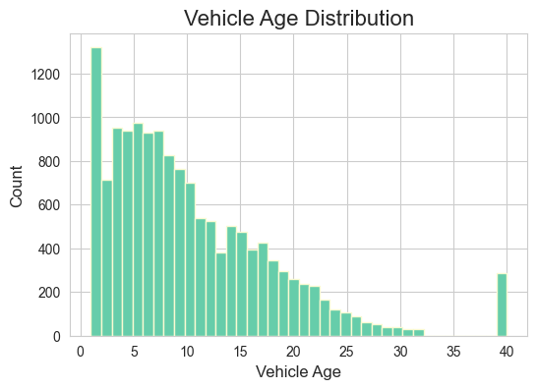
Figure 2 - Histogram

Boxplot: Vehicle Age by Make
Figure 3 shows clear differences in vehicle age across manufacturers. Pontiac has one of the highest median ages, which makes sense given that the brand was discontinued in 2010, meaning any remaining vehicles are at least 14 years old. Tesla shows one of the lowest median ages, consistent with it being a newer brand. Most mainstream brands like Toyota, Ford, and Honda fall in the 7 to 12 year range. Harley Davidson also stands out with a relatively high median age, suggesting owners tend to hold onto their motorcycles for a long time. Most vehicles across all makes have an average age in the 7 to 10 year range, and the spread of the boxes shows that vehicle age varies quite a bit even within a single brand.
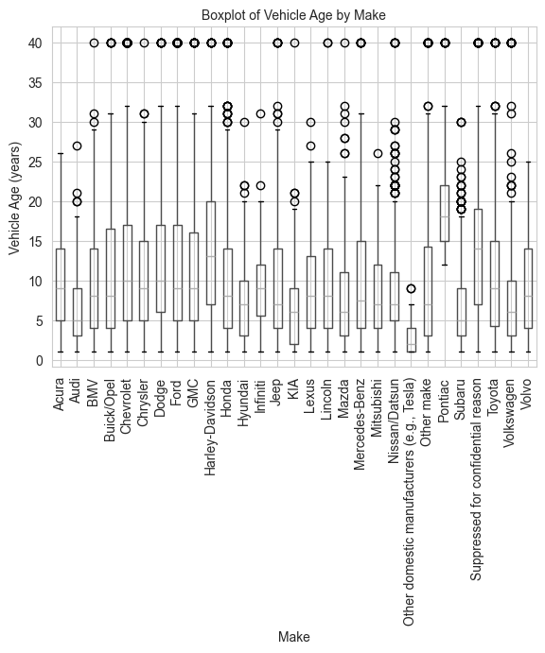
Figure 3 - Boxplot

Time-Series Dashboard: Trajectory 10
Figure 4 shows the four-panel time-series dashboard for trajectory 10. The position plot shows both vehicles moving along an increasing position curve as expected for highway driving, with the follower tracking closely behind the leader throughout. The speed plot shows both vehicles fluctuating between roughly 5 and 20 m/s, with the follower speed mirroring the leader with a slight delay that reflects normal human reaction time. The acceleration plot shows both vehicles alternating between positive and negative values, with the follower broadly matching the leader's pattern but with some differences in timing. The gap distance plot shows that the spacing between vehicles was not constant and fluctuated throughout the observation period, indicating the follower was actively adjusting speed in response to the leader.
These plots are useful to the transportation industry because they show how real drivers behave in traffic. The lag between leader and follower behavior and the resulting gap fluctuations are exactly the kinds of dynamics that need to be understood when designing safe following distance standards, developing adaptive cruise control systems, and building traffic simulation models.
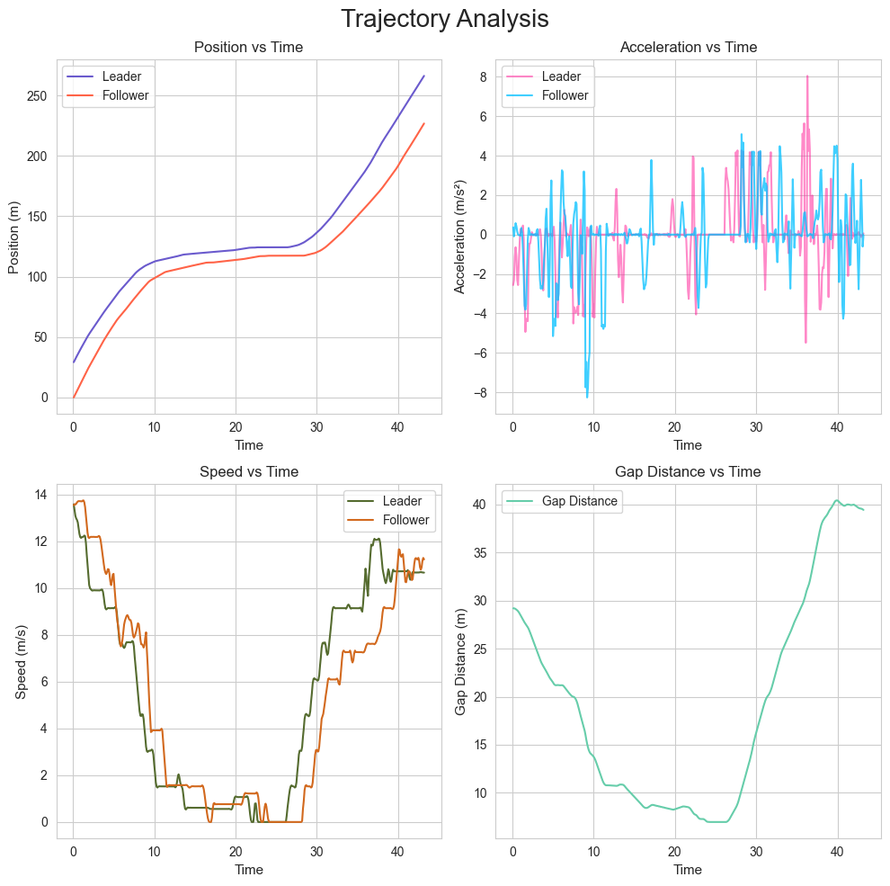
Figure 4 - Time-Series Dashboard

IDM Simulation: Simulated vs Real Trajectory
As shown in Figure 5, the simulated follower position tracks very closely with the real NGSIM follower position for most of the observation period. The lines are nearly identical through most of the trajectory, which shows the model is well calibrated with the default parameters. The biggest differences appear toward the end of the time period, where the lines begin to diverge slightly. This is likely because the real driver may begin responding to cues or slowing down slightly before the simulation expects it, since the IDM can only react to the current state of the leader and cannot anticipate what is coming next the way a human can. Overall the close match between the simulated and real trajectories confirms that the IDM is a reliable tool for modeling car-following behavior under normal highway conditions.
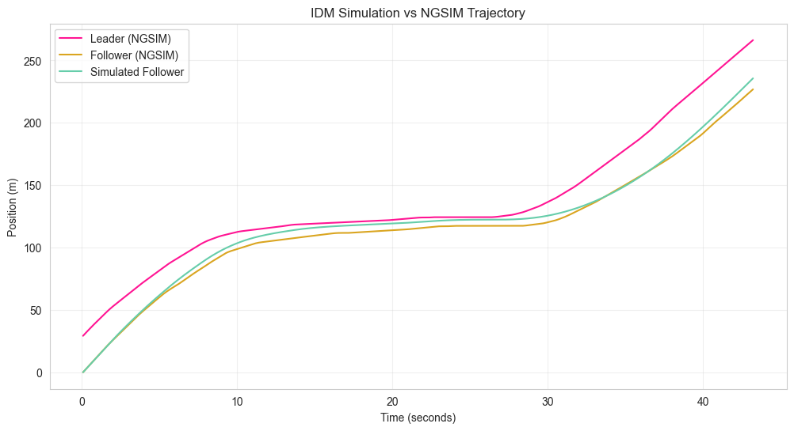
Figure 5 - IDM Simulation

References
Federal Highway Administration. (2006). Next Generation Simulation (NGSIM). U.S. Department of Transportation. https://ops.fhwa.dot.gov/trafficanalysistools/ngsim.htm
Federal Highway Administration. (2022). National Household Travel Survey. U.S. Department of Transportation. https://nhts.ornl.gov
Treiber, M., Hennecke, A., and Helbing, D. (2000). Congested traffic states in empirical observations and microscopic simulations. Physical Review E, 62(2), 1805-1824.

